State Association &/or
New England Association of City & Town Clerks (NEACTC) New England Municipal Clerks Institute & Academy (NEMCI&A)

2025 Scholarship Application
Yes No
- I am a Municipal Clerk/Deputy/Assistant Clerk, or Staff Member. 
- I am the only applicant from my municipality.
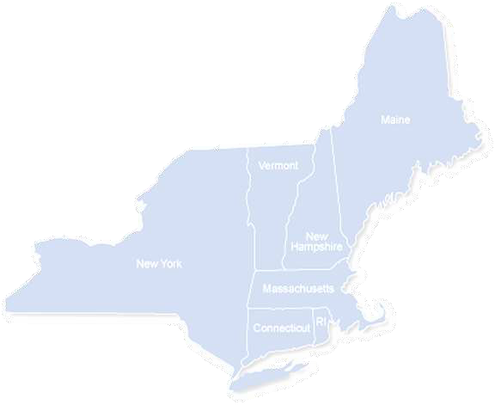
- I have been denied all or partial funding from my municipality and I am  enclosing the letter of denial.
- I am a member in good standing of my state association.
- I am a member of NEACTC and current on my Annual Membership fee. If you have answered YES to all of the above, you may apply for financial assistance.
If you have answered NO to any of the above, you must include a letter of explanation stating why you have not complied with the above criteria.

Name |  |  |  |  | Date
Job Title/Municipality |  |  |  |  | Population
Address
Email
PH |  | Fax
Inst. Year | or Academy | If Academy, year graduated from Institute
I am applying for financial assistance for NEMCI |  |  | Amount Requested $ __**
Deposit from Town or Attendee-Minimum $100. $ ______________** |  | **Enter requested amount above-Total Fee MINUS Town/Attendee Contribution
I have have not applied to IIMC for scholarship funds. |  |  |  | IIMC will pay $

Return this application, letter of denial and any necessary correspondence to your State Scholarship Chair by your state deadline.
⇨⇨⇨Check with your State Scholarship Chair to see if you need additional paperwork ⇨⇨⇨
FOR USE BY STATE SCHOLARSHIP CHAIR ONLY
Date rec’d Date action taken
Amount Awarded $ OR Reason for denial

⇨⇨⇨After state action, State Scholarship Chair forwards to NEACTC Joint Chair by April 10, 2025 ⇨⇨⇨
FOR USE BY NEACTC/NEMCI JOINT SCHOLARSHIP COMMITTEECHAIR ONLY
Date received Date action taken
Amount Awarded $ OR Reason for denial

New England Municipal Clerks Institute & Academy (NEMCI&A)
Scholarship Criteria
- Scholarships shall be awarded to students attending NEMCI&A.
- Applicant must be a Municipal Clerk/Deputy/Assistant Clerk, or Staff Member.
- Priority to first year Institute students.
- An applicant must be a current member of their state association.
- An applicant must be a member of NEACTC and paid their Annual Membership fee by March 31st.
- Scholarship awards will be limited to one person per office with the Clerk having first preference.
- Applicant shall disclose at the time of application whether they have applied for IIMC funds.
- An applicant must have requested funds from their municipality and include a letter of denial for such funds.
Procedures and Deadlines
- Applicants shall, after denial from municipality, send this application, along with individual state application, if applicable, to their state association for consideration by state deadline. A reason for denial or explanation must accompany this application to be considered.
- Deadline for State Scholarship Chair to file applications with the Joint Scholarship Chair is April 10, 2025.
- Joint Scholarship Chair will notify the applicant, NEACTC & NEMCI&A Treasurers by April 30, 2025.

Joint Scholarship Chair
Joint scholarship chair refers to the person responsible for awarding scholarship funds from NEACTC and NEMCI&A and does not imply joint responsibility with another person. This is a three-year appointment.
New England Joint Scholarship Chair
Kathy Larkin
P.O. Box 152
Southington, CT 06489
PH (860) 276-6215
FAX (860) 276-6229

larkink@southington.org
STATE SCHOLARSHIP CHAIRS PHONE/FAX EMAIL STATE DEADLINE
CT Holly Krouse PH 860-379-8665 hkrouse@barkhamsted.us March 1st
67 Ripley Hill Rd. FAX 860-379-9284
Barkhamsted, CT 06063

MA Danielle Sicard PH 508-230-0530 dsicard@easton.ma.us April 1st
136 Elm St.
Easton, MA 02356

NH Sally Kellar PH 603-792-1306 skellar@bedfordnh.org March 1st
24 N. Amherst Rd. FAX 603-472-4573
Bedford, NH 03110

RI Keisha Phillips Brown PH 401-466-3200 x1 kbrown@newshorehamri.gov March 31st
PO Box 220 FAX 401-466-3219
New Shoreham, RI 02807

VT Sandra Pinsonault PH 802-362-1178 x2 dorsetclerk@gmail.com March 1st
PO Box 24 FAX 802-362-5156
East Dorset, VT 05253

ME Ann Morrison PH 207-794-3372 x9 ann.morrison@lincolnmaine.org March 1st
29 Main St. FAX 207-794-2606
Lincoln, ME 04457

